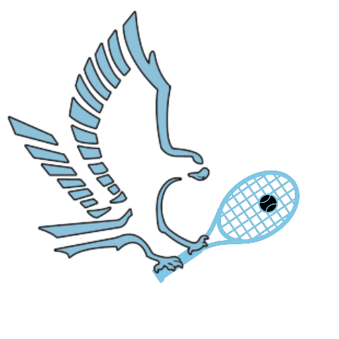Support Our Tennis Champions!

2024-25 Hawks Tennis Booster Club Sponsorship Opportunities

Please print and mail/Email in the form

Sponsorship Level (Circle)

Platinum Gold Silver Bronze Grand Slam Ace

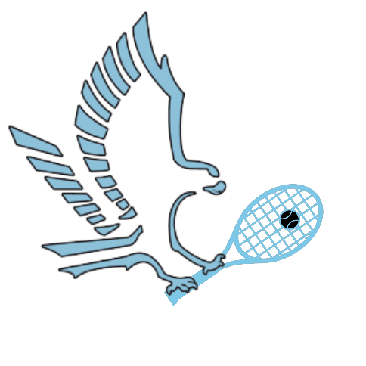Business Name:_____________________________________

Point of Contact:____________________________________

Donation Amount:___________________________________

Business Email:_____________________________________

Business Address:____________________________________

Social Media

Facebook:_____________________________________

Instagram:_____________________________________



Email business logos to [hawkstennisboosterclub@gmail.com](mailto:hawkstennisboosterclub@gmail.com)

Checks made payable to: Hawks Tennis Booster Club

*Tax ID and receipt will be mailed upon request

Mail To:

Hawks Tennis Booster Club

P.O. Box 26312

Yuma, AZ 85367

Contact Us:

Email: Hawkstennisboosterclub@gmail.com

Phone: (928) 235-6404