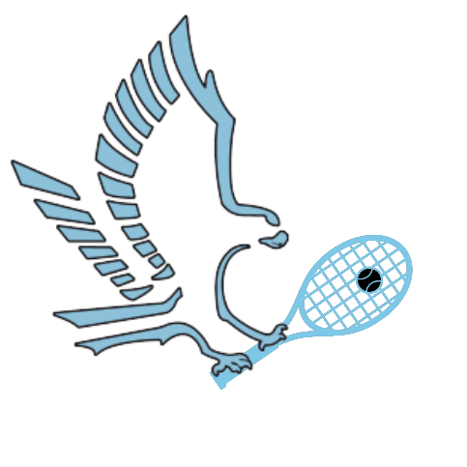

2024-25 Hawks Tennis Booster Club Sponsorship

Sponsorship Levels:

* Platinum Sponsorship: $1,000 donation, large (2’ x 6’) and small banner (2’ x3’) of your design ( your logo or Athlete shoutout), company’s name next to Platinum sponsorship on the Website, a video outside of your place of work with the Hawks Tennis Booster Club thanking you and posting on the website and social media platforms.
* Gold Sponsorship: $500.00: large banner, the company’s name next to Gold Sponsorship on the Website, and two separate posts on all media platforms.
* Silver Sponsorship: $300.00: large banner, company’s name next to Silver sponsorship on the Website, and one post on all social media platforms.
* Bronze Sponsorship: $200.00: large banner, company’s name next to Bronze sponsorship on Website.
* Grand Slam Sponsorship: $150.00: small banner, company’s name next to Grand Slam sponsorship on the Website.
* Ace sponsorship: $100.00: small banner, company’s name next to Ace sponsorship on the Website
* Don’t want a banner? No problem! Any donations are appreciated!!!





Contact Us:

Email: Hawkstennisboosterclub@gmail.com

Phone: (928) 235-6404